Profile of the

Vermilion County Metropolitan

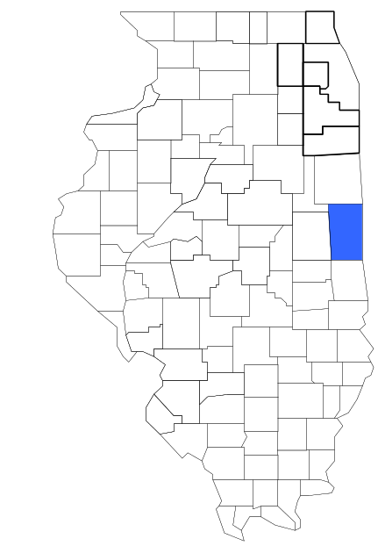Enforcement Group

Prepared by

The Research and Analysis Unit of the
Illinois Criminal Justice Information Authority

George H. Ryan, Governor
Peter B. Bensinger, Chairman
Candice M. Kane, Executive Director

March 2001



ILLINOIS
CRIMINAL JUSTICE
INFORMATION AUTHORITY

This project was supported by Grant # 99-DB-BX-0017, awarded to the Illinois Criminal Justice Information Authority by the Bureau of Justice Assistance, Office of Justice Programs, U.S. Department of Justice. The Assistant Attorney General, Office of Justice Programs, coordinates the activities of the following programs, offices and bureaus: Bureau of Justice Assistance, Bureau of Justice Statistics, National Institute of Justice, Office of Juvenile Justice and Delinquency Prevention, and the Office for Victims of Crime. Points of view or opinions contained within this document are those of the authors and do not necessarily represent the official position or policies of the U.S. Department of Justice.

Illinois Criminal Justice Information Authority
120 S. Riverside Plaza, Suite 1016
Chicago, Illinois 60606-3997
Telephone (312) 793-8550
Telefax (312) 793-8422
TDD: (312) 793-4170
World Wide Website http://www.icjia.state.il.us
ACKNOWLEDGMENTS

A number of organizations and individuals put a great deal of effort into the development of this document. The Authority’s Research and Analysis Unit is very grateful for the assistance provided by the following organizations:

Administrative Office of the Illinois Courts
Illinois Department of Human Services’ Office of Alcoholism and Substance Abuse
Illinois Department of Children and Family Services
Illinois Department of Corrections
Illinois State Police
Vermilion County Metropolitan Enforcement Group
U.S. Bureau of the Census

In addition, the following individuals were instrumental in gathering, interpreting and presenting these data:

Sharyn Adams

Megan Alderden

Robert Bauer

John Condne

Karen Griffiths

Tracy Hahn

David Katz

Joseph Kozenczak

Gary Kupsak

Erica Morrow

David Olson

Adrianna Perez

Gerard Ramker

Robert Taylor

CONTENTS

Section Page Number

EXECUTIVE SUMMARY

I. Introduction 1
II. Trends in Violent Index Offenses and Arrests 3
III. Trends in Drug Arrests 6
IV. Trends in Drug Seizures 15
V. Trends in Prosecutions for Drug Offenses 17
VI. Trends in Percent of Convicted Drug Offenders Sentenced to Prison 19
VII. Trends in Drug Treatment Admissions in VEMEG Region by Drug Type 24
VIII. Trends in Drug Exposed Births 27
IX. Summary of Drug Situation 28
X. Appendices 30
Map 1 1999 Percent of Illinois' County-level Population Covered by an
Authority-funded Multi-jurisdictional Enforcement Group or Task Force 31
Map 2 1999 Illinois Cannabis Seizure Rates, by County 32
Map 3 1999 Illinois Controlled Substances Seizure Rates, by County 33
Map 4 1999 Illinois Methamphetamine Seizure Rates, by County 34
XI. Bibliography 35

LIST OF FIGURES

Figure Page Number

Figure 1. Violent Index Offense Rates for Participating and Non-participating Agencies in Region Covered by VEMEG 3
Figure 2. 1999 Violent Index Offenses* Reported by Participating and Non-participating Agencies in Region Covered by VEMEG 4
Figure 3. Violent Index Arrest Rates for Participating and Non-participating Agencies in Region Covered by VEMEG 5
Figure 4. 1999 Violent Index Arrests* Reported by Participating and Non-participating Agencies in Region Covered by VEMEG 5
Figure 5. Total Drug Arrest Rates for VEMEG and Participating and Non-participating Agencies in Region Covered by VEMEG 7
Figure 6. 1999 Drug Arrests* Reported by Participating and Non-participating Agencies in Region Covered by VEMEG 8
Figure 7. Total 1999 Drug Arrests* Reported by Participating and Non-participating Agencies in Region Covered by VEMEG, by Drug Type 8
Figure 8. Drug Arrests by VEMEG 9
Figure 9. Percent of Total Drug Arrests Accounted for by VEMEG 10
Figure 10. Cannabis Arrests Rates in the Region Covered by VEMEG as Reported by Participating Agencies, Non-participating Agencies and VEMEG 11
Figure 11. Percent of Cannabis Arrests Accounted for by VEMEG
12
Figure 12. Controlled Substances Arrest Rates in the Region Covered by VEMEG as Reported by Participating Agencies, Non-participating Agencies and VEMEG 13
Figure 13. Percent of Controlled Substances Arrests Accounted for by VEMEG 14
Figure 14. VEMEG Drug Arrests for Possession versus Delivery, by Drug Type 14
Figure 15. Cannabis Seized and Submitted to ISP by Vermilion County and Seized by VEMEG 15
Figure 16. Powder and Crack Cocaine Seized and Submitted to ISP by Vermilion County and Seized by VEMEG 16
Figure 17. Number of Felony Filings in Vermilion County 17
Figure 18. Total VEMEG Drug Arrests and Percentage of Arrests Resulting in Prosecution 18
Figure 19. Sentences Imposed on Felons Convicted in Vermilion County
19
Figure 20. Sentences Imposed on Convicted VEMEG Drug Offenders 20
Figure 21. Number of Drug Offenders Committed to IDOC by VEMEG and Region Covered by VEMEG 21
Figure 22. Drug Offenders as a Percent of Total IDOC Commitments from Vermilion County 22
Figure 23. Drug Offenders Committed to IDOC from Vermilion County, by Offense Class 23
Figure 24. Substance Abuse Treatment Admissions from Vermilion County 24
Figure 25. Comparison of Drug Arrests by VEMEG and Participating and Non-participating Agencies vs. Drug Abuse Treatment Admissions in Vermilion County, 1999 26
Figure 26. Cases of Drug-Exposed Infants in Vermilion County 27
Figure 27. Availability of Drugs in Illinois, 1998 28
Figure 28. Price Per Gram in Illinois, 1998 29

EXECUTIVE SUMMARY

Since 1989, the Authority’s Research and Analysis Unit has received funds under the federal Anti-Drug Abuse Act of 1988 to document the extent and nature of drug and violent crime in Illinois and the criminal justice system’s response to these offenses. As a result of these efforts, the Authority has amassed a large amount of data measuring the extent and nature of drug and violent crime in Illinois and the impact these crimes have had on the criminal justice system. In addition, as part of its monitoring and evaluation efforts, the Authority also requires funded programs to submit monthly data reports describing their activities and accomplishments. This profile is intended to provide a general overview of the drug and violent crime problem in the jurisdictions covered by Illinois’ MEGs and task forces, and the response to these problems by the units.

Although the data presented in this report are by no means inclusive of all indicators, they do provide a general overview of drug and violent crime and the response and impact of the criminal justice system. The following represent general conclusions that can be made based on the data analyzed for this report.

- In 1999, eight local Illinois police agencies participated in VEMEG (a participating agency is defined as one that contributes either personnel or financial resources to VEMEG). Officers assigned to VEMEG (totaling nine in 1999, six from participating agencies) accounted for five percent of the total number of sworn police officers working for agencies participating in VEMEG.

- The violent Index offense rate was collectively higher across jurisdictions that participated in VEMEG than among the combined jurisdictions that did not participate in VEMEG (page 3).

- The drug arrest rate was collectively higher in those jurisdictions that participated in VEMEG than in those jurisdictions that did not participating in VEMEG. The drug arrest rate achieved by VEMEG during the same period was lower than the rates achieved by both participating and non-participating agencies (page 7).

- When comparing the types of drug offenders arrested by those agencies participating in VEMEG, those agencies not participating, and VEMEG, it was found that VEMEG tended to target and arrest more serious drug law violators, specifically violators of the Controlled Substances Act, which tend to be felony-level offenses (page 9).

- The majority of all drug arrests reported by VEMEG, for either violations of the Cannabis Control Act or the Controlled Substances Act, involve drug sale or delivery (page 14).

- Between 1993 and 1999, the amount of cannabis and cocaine seized by VEMEG increased (pages 15 and 16).

- Between 1991 and 1999, almost all drug arrests by VEMEG resulted in prosecution. Of those offenders prosecuted, 69 percent were prosecuted for violation of the Controlled Substances Act. In addition, between 1989 and 1999, 73 percent of all drug offenders who were prosecuted as a result of VEMEG activity were convicted (page 18).

- In 1999, among those VEMEG drug offenders convicted and sentenced, probation sentences accounted for the largest proportion (54 percent), followed by prison sentences (42 percent) and jail sentences (4 percent) (page 20).

- Between 1989 and 1999, prison sentences resulting from VEMEG cases accounted for 91 percent of all drug-law violators sent to prison from the region where VEMEG operates (page 21).

- Unlike the arrests made by the participating and non-participating agencies, the arrests made by VEMEG tended to involve substances considered to be the most serious (i.e., felony versus misdemeanor) and the substances for which a large proportion of community residents were seeking and receiving substance abuse treatment in 1999 (page 25).

I. Introduction

The Vermilion County Metropolitan Enforcement Group (VEMEG) covers the Illinois county of Vermilion which had a 1999 total population of 83,813 – 5 percent less than in 1990. In 1999, eight local Illinois police agencies participated in VEMEG. These include the Vermilion County Sheriff’s Office and the following municipal police departments: Aurora, Danville, Hoopeston, Georgetown, Catlin, Oakwood, Rankin and Rossville. These agencies served 87 percent of the population in the region covered by VEMEG in 1999 (see Map 1 on page 31). A participating agency is defined as one that contributes either personnel or financial resources to VEMEG.

In addition to agencies that participate in VEMEG, these Illinois counties are served by ten additional police departments that do not participate in VEMEG. According to the Illinois State Police, county sheriffs and local police departments, in the region covered by VEMEG, combined, employed 125 full-time police officers as of Oct. 31, 1999, 114 of which work in agencies participating in VEMEG. In comparison, there were nine officers assigned to VEMEG in 1999, six of which were assigned by participating agencies and three from the Illinois State Police (ISP). Thus, the officers assigned to VEMEG during 1999 accounted for a relatively small proportion—five percent—of the total number of sworn police officers working in the participating police departments.

Since 1989, the Authority’s Research and Analysis Unit has received funds under the federal Anti-Drug Abuse Act of 1988 to document the extent and nature of drug and violent crime in Illinois and the criminal justice system’s response to these offenses. As a result of these efforts, the Authority has amassed a large amount of data measuring the extent and nature of drug and violent crime in Illinois and the impact these crimes have had on the criminal justice system. In addition, as part of its monitoring and evaluation efforts, the Authority also requires funded programs to submit monthly data reports describing their activities and accomplishments. To put this information into the hands of Metropolitan Enforcement Group (MEG) and drug task force directors and policy board members, the Authority’s Research and Analysis Unit has developed profiles – of which this is one – for each MEG and task force. The profile is intended to provide a general overview of the drug and violent crime problem in the jurisdictions covered by Illinois’ MEGs and task forces, and the response to these problems by the units.

In addition to administering federal block-grant funds that come to Illinois for crime control initiatives, the Illinois Criminal Justice Information Authority is also responsible for providing policymakers, criminal justice professionals and others with information, tools and technology needed to make effective decisions that improve the quality of criminal justice in Illinois The Authority provides an objective system-wide forum for identifying critical problems in criminal justice, developing coordinated and cost-effective strategies, and implementing and evaluating solutions to those problems. The specific powers and duties of the Authority are delineated in the Illinois Criminal Justice Information Act (Illinois Compiled Statutes, Ch. 20, Sec. 3930). Two of the Authority’s many responsibilities are serving as a clearinghouse of information and research on criminal justice and undertaking research studies to improve the administration of criminal justice.

While the data presented in this report are by no means inclusive of all indicators, they do provide a general overview of drug and violent crime and the response and impact of the criminal justice system. In addition, these data are readily available and consistently defined through existing statewide data collection mechanisms. Some data presented in this profile have been analyzed differently than in previous years; therefore, caution must be taken when comparing numbers presented with previous profiles.
While a considerable amount of the information presented in this profile has been provided to the Authority by VEMEG, a number of state agencies have also provided data to the Authority that are included in this report. Specifically, the Illinois State Police, the Administrative Office of the Illinois Courts, the Illinois Department of Human Services’ Office of Alcoholism and Substance Abuse, the Illinois Department of Corrections and the Illinois Department of Children and Family Services all provided data used to develop this profile. The support and cooperation of these agencies and their staffs have helped make this report an informative and timely source of information on the activities of the criminal justice system in Illinois.

- Trends in Violent Index Offenses and Arrests

While most of Illinois’ Metropolitan Enforcement Groups and drug task forces are primarily involved in drug enforcement activities, it is clear that the relationship between drugs and violence is particularly evident in a number of Illinois communities. In addition, a number of MEGs and task forces have increased their involvement in the investigation of violent crime, particularly that associated with gang activity and violence related to drug distribution, sale and turf battles. One of the most commonly used indicators of the level of crime in a particular jurisdiction is the number of Index offenses reported to the police. In Illinois, as part of the Illinois Uniform Crime Reporting (I-UCR) program, every law enforcement agency in the state is required to report crime data monthly to the Illinois State Police (ISP). There are eight separate offenses that constitute the Crime Index, including murder, criminal sexual assault, robbery, aggravated assault (violent Index offenses), burglary, theft, motor vehicle theft and arson (property Index offenses). Although these eight offenses do not account for all crimes reported to the police, they are considered to be the most serious, frequent, pervasive and consistently defined by different law enforcement agencies.

In 1999, the number of violent Index offenses reported to the police in the region covered by VEMEG totaled 651, a 34 percent decrease from the 986 offenses reported in 1993. The majority (74 percent) of violent Index offenses reported to the police between 1993 and 1999 were aggravated assaults, while 15 percent were robberies.

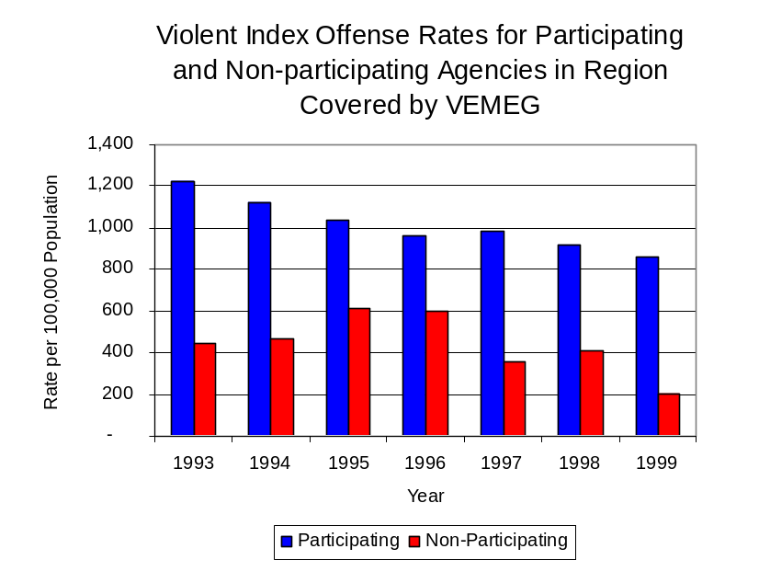
During the period analyzed, the violent Index offense rate for the region covered by VEMEG decreased 31 percent, from 1,126 offenses per 100,000 population in 1993 to 777 offenses per 100,000 population in 1999. Similarly, the violent Index offense rate in the participating agencies decreased 30 percent, from 1,222 to 859 offenses per 100,000 population, while the rate in the non-participating agencies decreased 54 percent, from 448 to 208 offenses per 100,000 population (Figure 1). Thus, the violent Index offense rate was collectively higher across the jurisdictions that participated in VEMEG than across those jurisdictions that did not participate in VEMEG.
Source: ICJIA calculations using
Illinois State Police and U.S. Census Bureau data
Figure 1

Across the 18 individual local law enforcement agencies covered by VEMEG’s jurisdiction, two agencies, the Danville Police Department and the Vermilion County Sheriff’s Office accounted for 89 percent of all violent offenses reported to the police (Figure 2). Eleven agencies had fewer than five violent offenses reported in 1999 and are excluded from Figure 2. When controlling for differences in the populations served by these law enforcement agencies, the violent Index offense rate ranged from 1,418 violent Index offenses per 100,000 population in Danville to 313 offenses per 100,000 population in Oakwood.
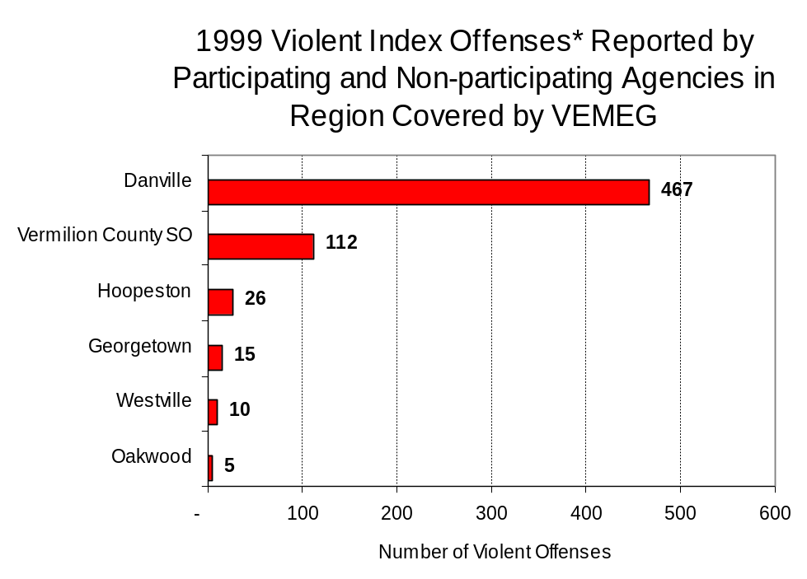
Source: Illinois State Police *Agencies reporting five or more violent offenses
Figure 2
An indicator of the workload that law enforcement agencies place on other components of the justice system is the number of arrests made by police, including those for violent and property Index offenses and drug offenses. Unlike offenses, which are what police must respond to, arrests represent those offenders who may eventually be processed through other components of the justice system, including the courts, county jails, and state and local correctional programs.

Between 1993 and 1999, the number of arrests for violent Index offenses made by law enforcement agencies in the region covered by VEMEG decreased 50 percent, from 496 to 250. As with reported violent Index offenses, the majority (83 percent) of violent Index arrests were for aggravated assaults, followed by robberies (9 percent).

During the period analyzed, the violent Index arrest rate for the region covered by VEMEG decreased 47 percent, from 566 offenses per 100,000 population in 1993 to 298 arrests per 100,000 population in 1999. Similarly, the violent Index arrest rate in the participating agencies decreased 48 percent, from 608 to 318 offenses per 100,000 population, while the rate in the non-participating agencies decreased 42 percent, from 275 to 160 offenses per 100,000 population (Figure 3).

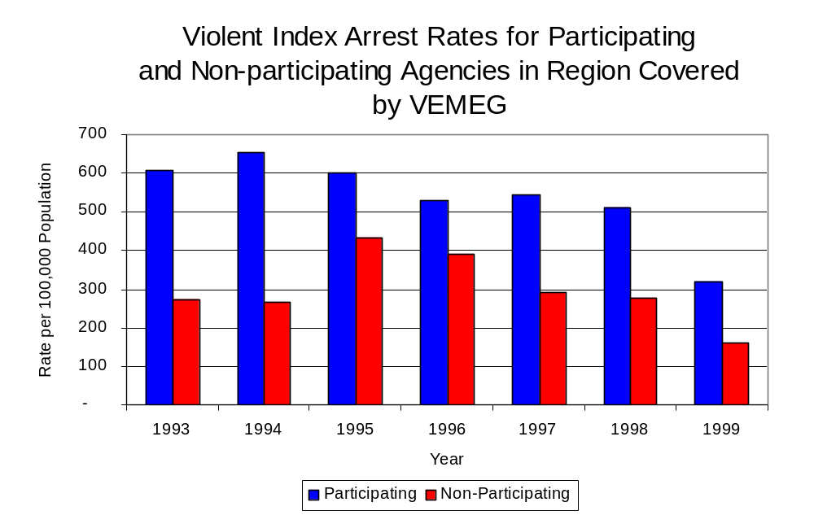
Sixty-three percent of the 250 arrests for violent Index offenses occurring in the region covered by VEMEG were made by the Danville Police Department (Figure 4). Twelve agencies had fewer than five arrests for violent Index offenses reported in 1999 and are excluded from Figure 4.
Figure 3
Source: ICJIA calculations using
Illinois State Police and U. S. Census Bureau data

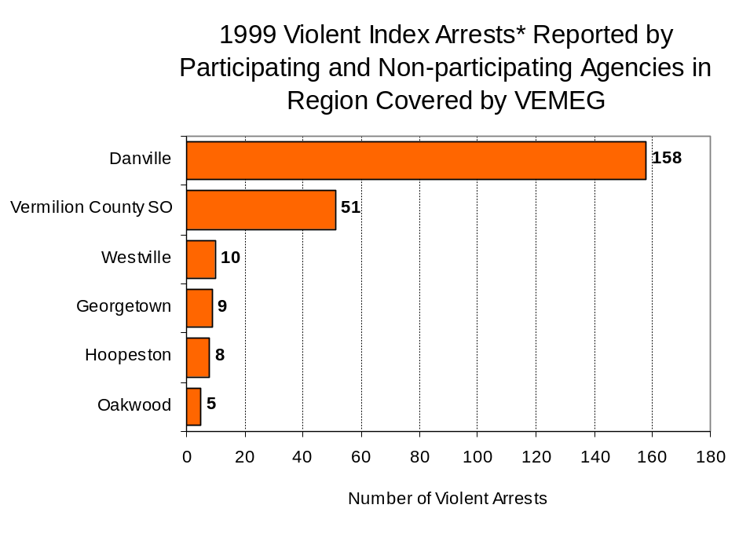
Figure 4
Source: Illinois State Police *Agencies reporting five or more violent offenses
III. Trends in Drug Arrests

There are two sources of drug arrest data presented in this section. One source is the Illinois Uniform Crime Reporting (I-UCR) program that includes information submitted by local law enforcement agencies on the number of persons arrested for violations of Illinois’ Cannabis Control Act, Controlled Substances Act, Hypodermic Syringes and Needles Act, and Drug Paraphernalia Control Act. In addition, data on drug arrests made by Illinois’ MEGs and task forces are reported to the Illinois Criminal Justice Information Authority. In some jurisdictions, arrests made by the MEG or task force may be reported by both local law enforcement agencies through the I-UCR and to the Authority by the unit. In other jurisdictions, arrests made by the MEG or task force are only reported to the Authority by the unit. Therefore, in some instances drug arrests may be double counted – included in both local agency statistics reported to I-UCR and those of the MEG or task force. Currently there is no mechanism in place to ensure that drug arrest statistics are not being duplicated at both the local agency and MEG/task force level. This should be kept in mind when interpreting the information presented in the following section.

The majority of drug offenses in Illinois are violations of either the Cannabis Control Act – which prohibits the possession, sale and cultivation of marijuana – or the Controlled Substances Act – which prohibits the possession, sale, distribution or manufacture of all other illegal drugs, such as cocaine and opiates. Illinois also has various other laws prohibiting other drug-related activity. These include the Hypodermic Syringes and Needles Act – which prohibits the possession or sale of hypodermic instruments – and the Drug Paraphernalia Control Act – which prohibits the possession, sale or delivery of drug paraphernalia. In general, violations of Illinois Controlled Substances Act are considered to be more serious, since they primarily involve cocaine, heroin, methamphetamine, and hallucinogens, and are almost all classified under Illinois law as felonies. The majority of cannabis and drug paraphernalia offenses encountered by police, on the other hand, tend to be misdemeanor-level offenses.

In 1999, local law enforcement agencies in the counties covered by VEMEG reported 293 arrests for drug law violations, a 26 percent increase from 1993 (233 arrests). Between 1993 and 1999, arrests for violations of Illinois’ Cannabis Control Act out-numbered arrests for violations of the Controlled Substances Act every year analyzed in Vermilion County. During the same period, the number of arrests for violations of the Cannabis Control Act increased 13 percent, from 143 to 161. Arrests for violations of the Controlled Substances Act increased 11 percent, from 84 to 93. In addition, arrests for violations of the Drug Paraphernalia Control Act, enacted in 1993, increased 5 in 1993 to 36 in 1999. Much of this increase can be attributed to a 1994 addition to the Drug Paraphernalia Control Act, which included the possession of drug paraphernalia as a violation.

Because arrests for violations of the Drug Paraphernalia Control Act are frequently made in conjunction with other drug offense arrests, these arrests may be double-counted, thus skewing the actual number of drug arrests. Therefore, only arrests for violations of the Cannabis Control Act and Controlled Substances Act will be used for drug arrest comparisons between VEMEG and the participating and non-participating agencies.

During the period analyzed, the drug arrest rate for violations of the Cannabis Control and Controlled Substances Acts combined, in the region covered by VEMEG increased 17 percent, from 259 arrests per 100,000 population in 1993 to 303 arrests per 100,000 population in 1999. Similarly, the drug arrest rate in the participating agencies increased 14 percent, from 279 to 317, while the drug arrest rate for non-participating agencies increased 74 percent from 119 to 208 arrests per 100,000 population. The arrest rate for VEMEG also decreased 24 percent, from 146 to 111 arrests per 100,000 population (Figure 5). Thus, the drug arrest rate for agencies participating in VEMEG was collectively higher than the drug arrest rate achieved by agencies not participating in VEMEG. In addition, the drug arrest rate achieved by VEMEG was lower than that achieved by agencies participating in VEMEG and this difference became greater in subsequent years.
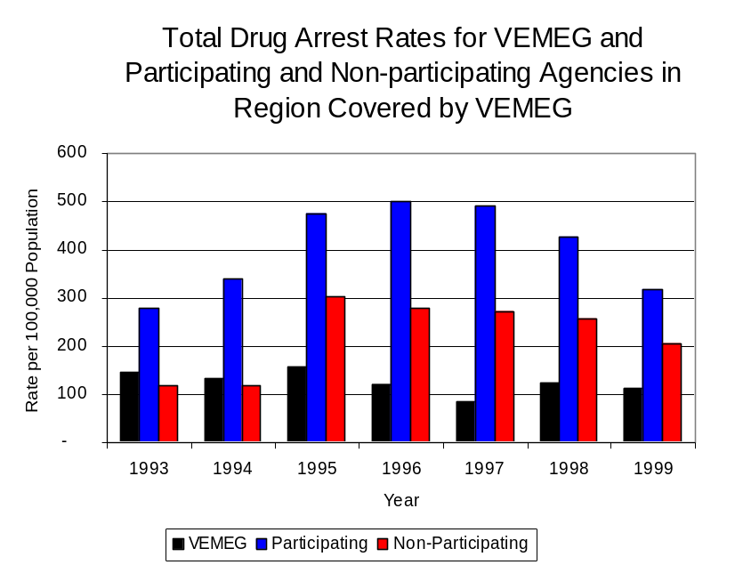
Source: ICJIA calculations using Illinois State Police, VEMEG and U.S. Census Bureau data
Figure 5

Across the local law enforcement agencies in the region covered by VEMEG, total number of drug arrests, including the Cannabis Control Act, the Controlled Substances Act, the Drug Paraphernalia Act and the Hypodermic Syringes and Needle Act ranged from zero to 153. Of the 293 drug arrests made during 1999 in the region, the Danville Police Department accounted for 52 percent of these drug arrests (Figure 6). Eleven agencies had fewer than five drug arrests reported in 1999 and are excluded from Figure 6. Among those agencies listed in Figure 6, the top four agencies, that reported the highest number of drug arrests, participated in VEMEG.

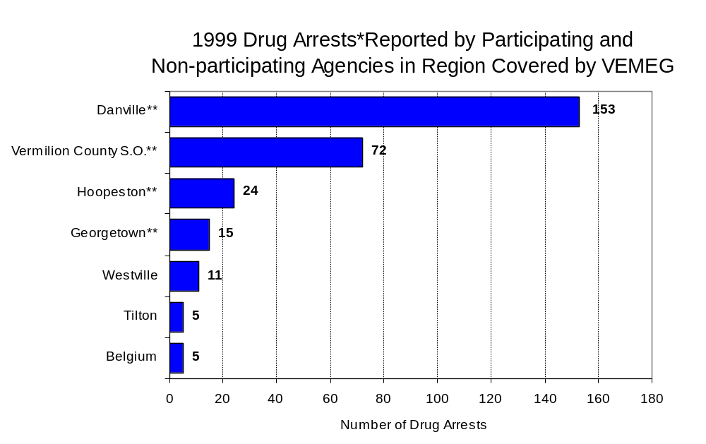
In addition to the dramatic difference in the number of drug arrests made, there are also
Figure 6
Source: Illinois State Police *Agencies reporting five or more drug arrests
**Agencies participating in VEMEG
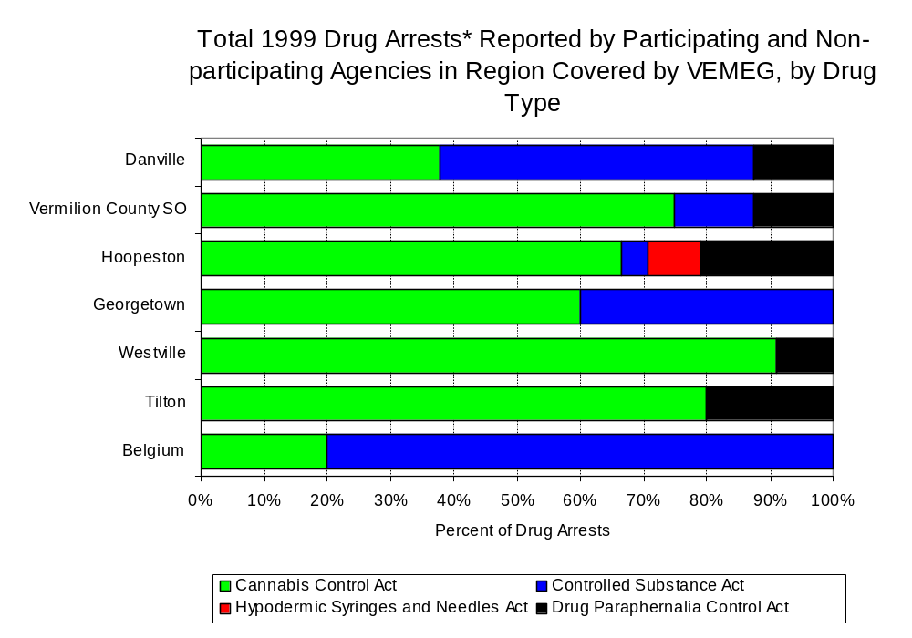
differences in the types of drug law violation arrests across the agencies in the region. In 1999, violations of the Cannabis Control accounted for the majority of arrests across most individual agencies in the region covered by VEMEG (Figure 7). However, for the Danville Police Department and the Belgium Police Department, arrests for the violation of the Controlled Substances Act accounted for over 50 percent of all drug arrests.
Figure 7
Source: Illinois State Police *Agencies reporting five or more drug arrests

Between 1993 and 1999, the number of combined cannabis and controlled substances arrests made by VEMEG decreased 28 percent, from 112 to 81 (Figure 8). Unlike drug arrests made by most local police departments in the region, violations of the Controlled Substances Act accounted for the majority of drug arrests made by VEMEG throughout all of the period analyzed. During the period analyzed, the number of VEMEG arrests for violations of the Cannabis Control Act decreased 34 percent, from 41 to 27, while arrests for violations of the Controlled Substances Act decreased 24 percent, from 71 to 54 (Figure 8).

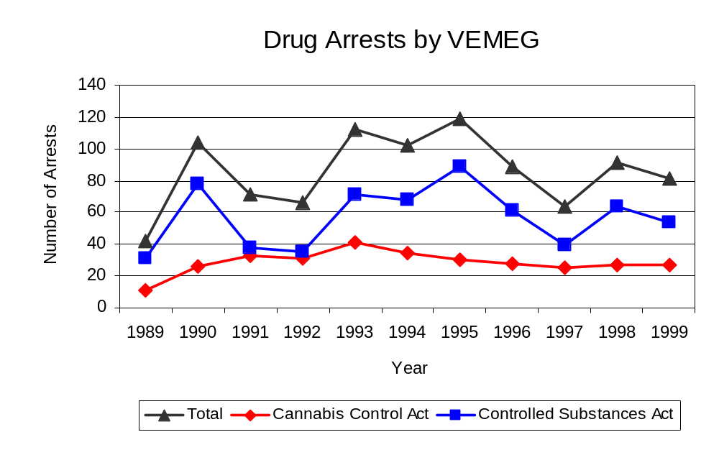
Between 1993 and 1999, the proportion of drug arrests accounted for by controlled substance violations remained relatively stable for participating, from 39 percent in 1993 to 38 percent in 1999, and increased for non-participating agencies, from 8 percent in 1993 to 18 percent in 1999. On the other hand, for VEMEG, the proportion of drug arrests accounted for by controlled substance violations increased five percent between 1993 and 1999, from 63 percent in 1993 to 67 percent in 1999. Based on these data, it can be inferred that arrests by VEMEG were more likely than arrests by either participating or non-participating agencies to involved violations of the Illinois’ Controlled Substances Act, as opposed to the Cannabis Control Act. One interpretation of this pattern is that VEMEG is more focused in who they are targeting and arresting than local departments, and are also getting a more serious drug law violator, since violations of the Controlled Substances Act are more likely to involve felony-level offense.
Source: VEMEG
Figure 8

The data presented below represent the percent of total drug arrests made by participating agencies that were accounted for by VEMEG. An upper and lower bound is shown in Figure 9, which accounts for whether or not the units numbers are counted as part of the UCR submissions made by participating departments (which is unknown at this point). The upper bound indicates the percentage of arrests if all of the VEMEG arrests are included in the local UCR submissions. The lower bound indicates the percentage if none of the VEMEG arrests are included in the local UCR submissions.

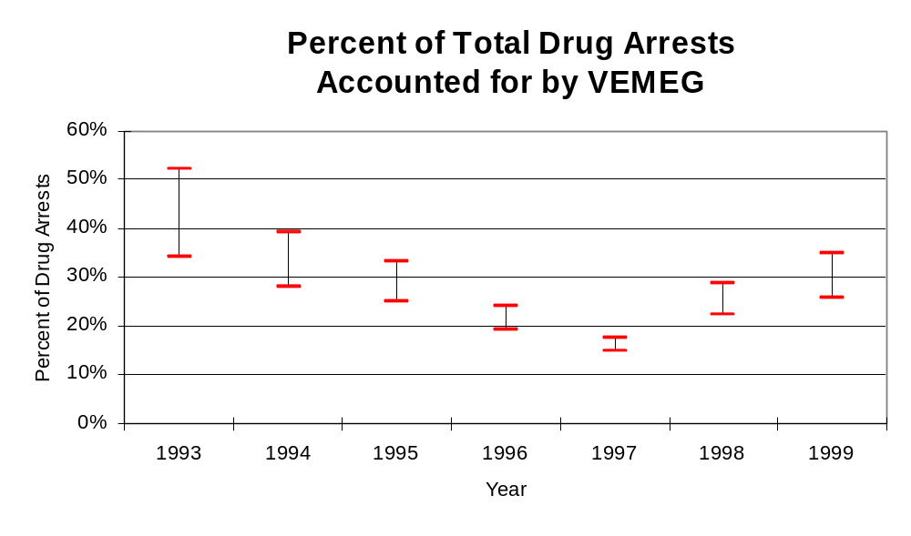
It is estimated that the proportion of all drug arrests made in the jurisdictions of participating agencies, and accounted for by VEMEG, was between 34 to 52 percent in 1993, but decreased to between 26 to 35 percent in 1999. Thus, despite the fact that the officers assigned to VEMEG accounted for a small proportion of the total number of officers in participating agencies, they accounted for a moderate proportion of the drug arrests made in the jurisdiction of the participating agencies in most of the years analyzed.
Figure 9
Source: ICJIA calculations using
Illinois State Police and VEMEG

The number of arrests for violations of Illinois’ Cannabis Control Act in Vermilion County totaled 161 in 1999, 13 percent more than the 143 arrests made for cannabis violations in 1993. Between 1993 and 1999, the proportion of all drug arrests accounted for by violations of the Cannabis Control Act in the region remained stable at 63 percent. Agencies participating in VEMEG accounted for the largest portion (91 percent) of the total number of arrests for cannabis violations between 1993 and 1999. VEMEG reported a total of 27 arrests for cannabis violations in 1999, 33 percent of the unit's drug arrests.

During the period analyzed, the cannabis arrest rate for the region covered by VEMEG increased 18 percent, from 163 arrests per 100,000 population in 1993 to 192 arrests per 100,000 population in 1999. The cannabis arrest rate in the participating agencies increased slightly, from 171 to 195 arrests per 100,000 population, while the arrest rate in the non-participating agencies increased from 110 to 170 arrests per 100,000 population. The cannabis arrest rate for VEMEG, on the other hand, decreased 31 percent, from 53 to 37 arrests per 100,000 population (Figure 10). Thus, the arrest rate for violations of the Cannabis Control Act was collectively higher in the area served by participating agencies than in the combined jurisdictions of the non-participating agencies.

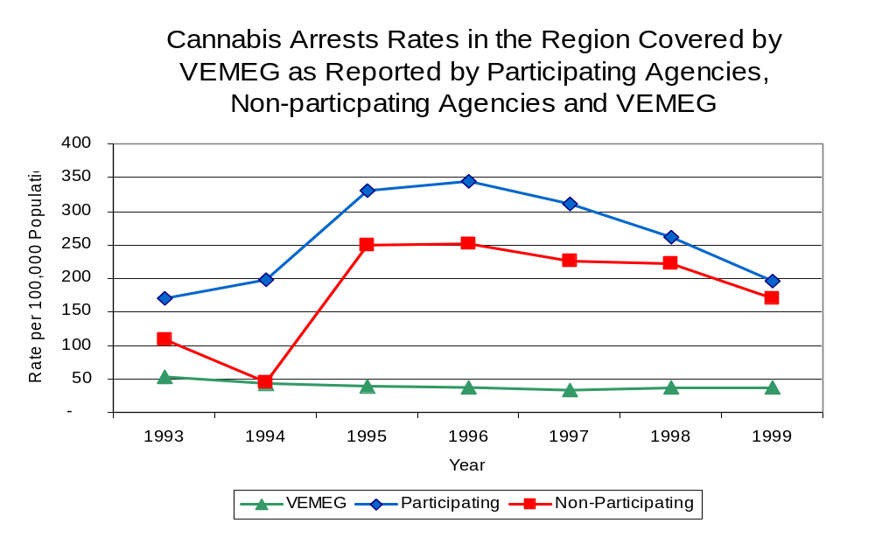
Source: ICJIA calculations using
Illinois State Police and VEMEG data
Figure 10

The data presented below represent the percent of total arrests for the violation of the Cannabis Control Act made by participating agencies that was accounted for by VEMEG. An upper and lower bound is shown in Figure 11, which accounts for whether or not the units numbers are counted as part of the UCR submissions made by participating departments (which is unknown at this point). The upper bound indicates the percentage of arrests if all of the VEMEG arrests are included in the local UCR submissions. The lower bound indicates the percentage if none of the VEMEG arrests are included in the local UCR submissions.

It is estimated that the proportion of all arrests for the violation of the Cannabis Control Act made in the jurisdictions of participating agencies, and accounted for by VEMEG, was between 24 to 31 percent in 1993, but decreased to between 16 to 19 percent in 1999. The data suggest that although arrests for the violation of the Cannabis Control Act made by VEMEG in 1993 represented a moderate proportion of such arrests made in the jurisdictions of participating agencies, this proportion dropped in subsequent years.

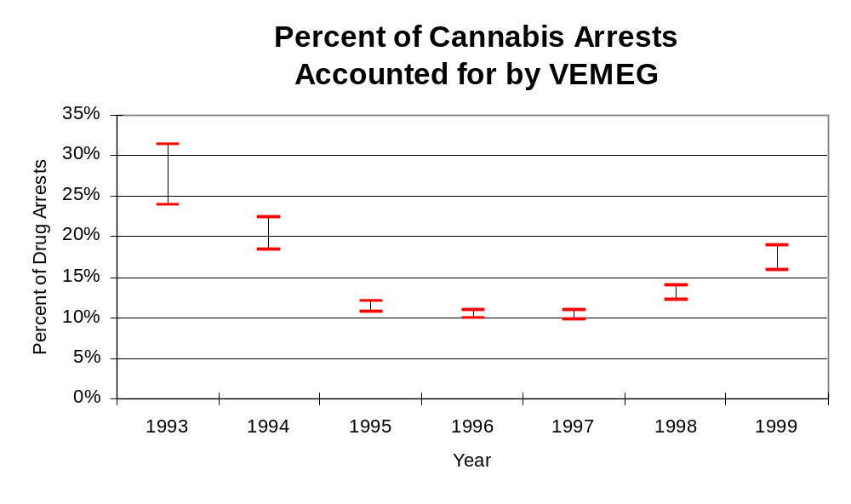
Figure 11
Source: ICJIA calculations using
Illinois State Police and VEMEG data
In Vermilion County the number of arrests for violations of Illinois’ Controlled Substances Act increased 11 percent between 1993 and 1999, from 84 to 93. Between 1993 and 1999, the proportion of all drug arrests accounted for by violations of the Controlled Substances Act in the region remained stable at 37 percent. In 1999, VEMEG reported 54 arrests for controlled substance violations, 67 percent of all drug arrests reported to the Authority by the unit.

Between 1993 and 1999, the arrest rate for Controlled Substances Act violations for the region covered by VEMEG increased 16 percent, from 96 to 111 arrests per 100,000 population (Figure 12). The controlled substances arrest rate in the participating agencies increased 12 percent from 108 to 122 arrests per 100,000 population, while the arrest rate in the non-participating agencies increased, from nine to 38 arrests per 100,000 population. The controlled substances arrest rate for VEMEG decreased 20 percent, from 93 to 74 arrests per 100,000 population (Figure 12). Thus, the arrest rate for violations of the Controlled Substances Act for participating agencies was collectively higher than the arrest rate for non-participating agencies. In addition, although VEMEG had only a small proportion of the officers working in Vermilion County, they achieved an arrest rate for violations of the Controlled Substances Act that was higher than the non-participating agencies and relatively close to those agencies participating in VEMEG.

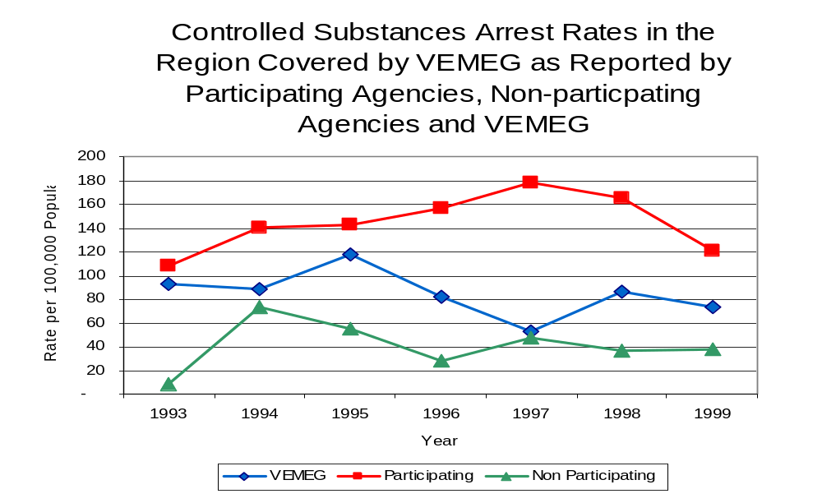
Figure 12
Source: ICJIA calculations using Illinois State Police and VEMEG data

The data presented below represent the percent of total arrests for the violation of the Controlled Substances Act made by participating agencies that was accounted for by VEMEG. An upper and lower bound is shown in Figure 13, which accounts for whether or not the units numbers are counted as part of the UCR submissions made by participating departments (which is unknown at this point). The upper bound indicates the percentage of arrests if all of the VEMEG arrests are included in the local UCR submissions. The lower bound indicates the percentage if none of the VEMEG arrests are included in the local UCR submissions.

It is estimated that the proportion of all arrests for the violation of the Controlled Substances Act made in the jurisdictions of participating agencies, and accounted for by VEMEG, was between 46 to 86 percent in 1993, but decreased to between 38 to 61 percent in 1999. Arrests made by VEMEG for violations of the Controlled Substances Act represented a large proporation of similar arrests made in the jurisdictions of the participating agencies, even though VEMEG had relatively few officers assigned to the task force. When examining the three figures together (Figure 9, 11 and 13), the data suggest that VEMEG focused on arresting individuals violating the Controlled Substances Act, most of which are felony offenses

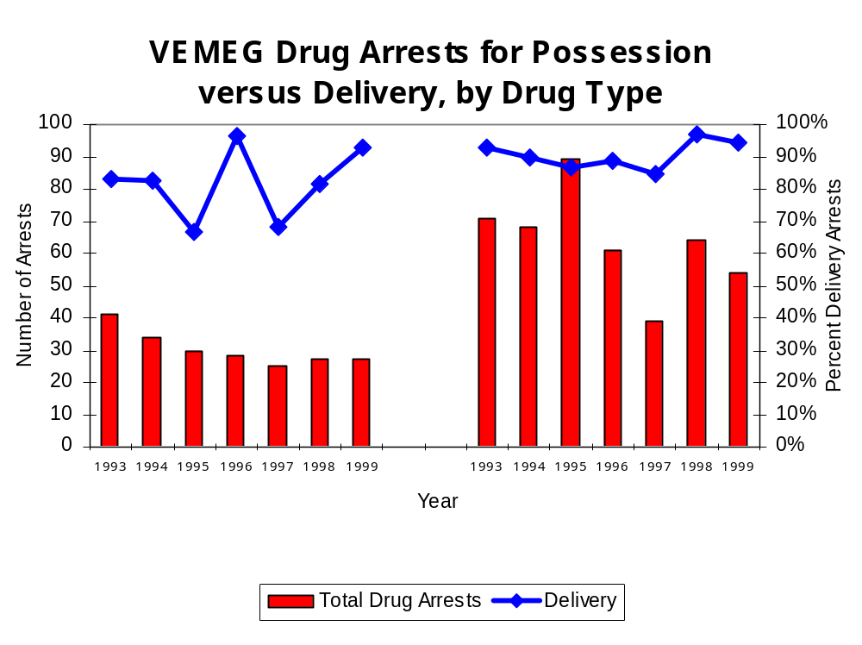
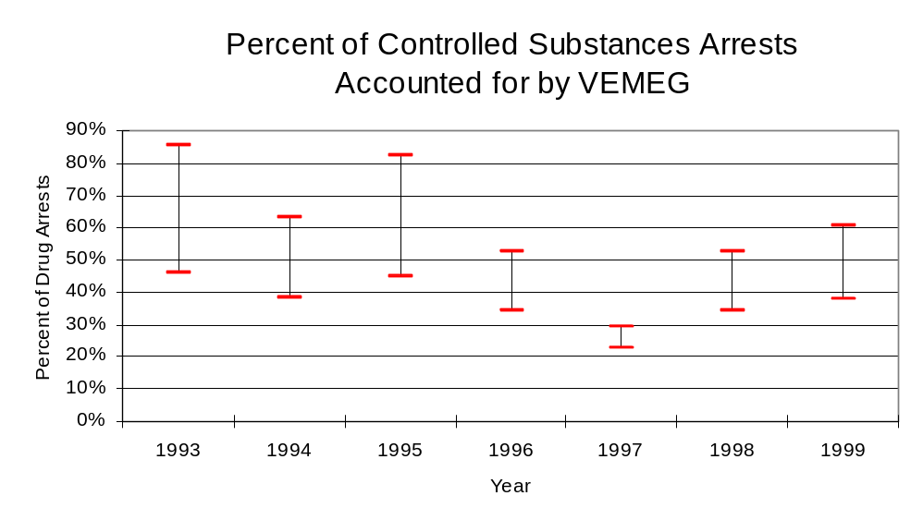
The majority of all drug arrests reported by VEMEG are for delivery. Between 1993 and 1999, the number of drug delivery arrests made by VEMEG decreased from to 100 to 76 drug delivery arrests. Arrests for drug delivery accounted for 88 percent of all drug arrests made by VEMEG between 1993 and 1999. When cannabis and controlled substance arrests were examined separately, arrests for delivery of controlled substances accounted for 91 percent of the total number of arrests made for violations of the Controlled Substance Act, whereas, arrests for the delivery of cannabis accounted for 82 percent of all arrests for violations of the Cannabis Act.
Figure 14
Source: ICJIA calculations using VEMEG data
Cannabis Control Act
Controlled Substances Act
Figure 13
Source: ICJIA calculations using
Illinois State Police and VEMEG data
IV. Trends in Drug Seizures

Drugs seized by law enforcement agencies are another indicator of the extent and nature of illegal drug trade in a jurisdiction. When illegal drugs are seized by law enforcement agencies, all or a portion of the total amount seized is submitted to a crime lab for analysis. Most agencies submit drugs to one of the Illinois State Police crime labs. These labs record the quantity of drugs submitted from each county. This section discusses trends in the quantities of illegal drugs seized and submitted to the Illinois State Police from local law enforcement agencies in Vermilion County as well as the quantities of drugs seized by VEMEG. It is important to note, however, that while VEMEG data report the total quantities of drugs actually seized, local agency data only represent the quantities of seized drugs that are submitted to the Illinois State Police for analysis. County-level cannabis, cocaine and methamphetamine seizure rates for Illinois' 102 counties are provided in maps located in the Appendix of this report.

As in most Illinois jurisdictions, cannabis accounts for the majority of illegal drugs seized in the region covered by VEMEG. The quantity of cannabis seized and submitted by law enforcement agencies in Vermilion County decreased 84 percent, from 142,215 grams in 1993 to 22,798 grams in 1999, with 220,050 grams being seized in 1994, the largest amount seized during the period analyzed. However, the quantity of cannabis seized by VEMEG increased dramatically between 1993 and 1999, from grams 793,498 to 4,789,889 grams despite a decreasing trend between 1995 and 1998 (Figure 15). In 1999, VEMEG's cannabis seizure rate of 6,542,581 grams per 100,000 population was significantly higher than the statewide cannabis seizure rate of 31,533 grams per 100,000 population and the seizure rate of 27,200 grams per 100,000 population in the region covered by VEMEG (Map 2).
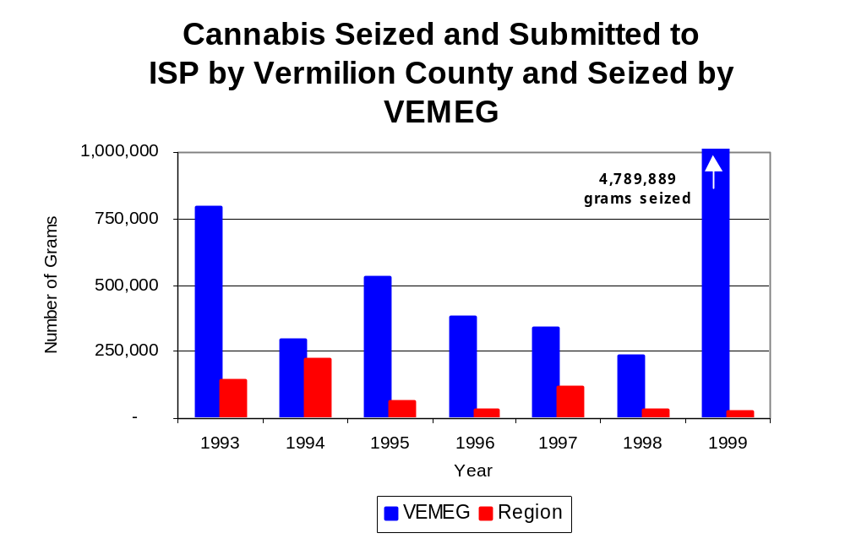
Figure 15
Source: Illinois State Police and VEMEG
Between 1993 and 1999, a combination of crack and powder cocaine has accounted for a small proportion of drugs seized in the region covered by VEMEG. However, the quantity of cocaine seized and submitted by law enforcement agencies in Vermilion County increased 35 percent, from 636 grams in 1993 to 858 grams in 1999. Between 1993 and 1999, the quantity of cocaine seized by VEMEG increased dramatically, from 408 grams to 6,398 grams.

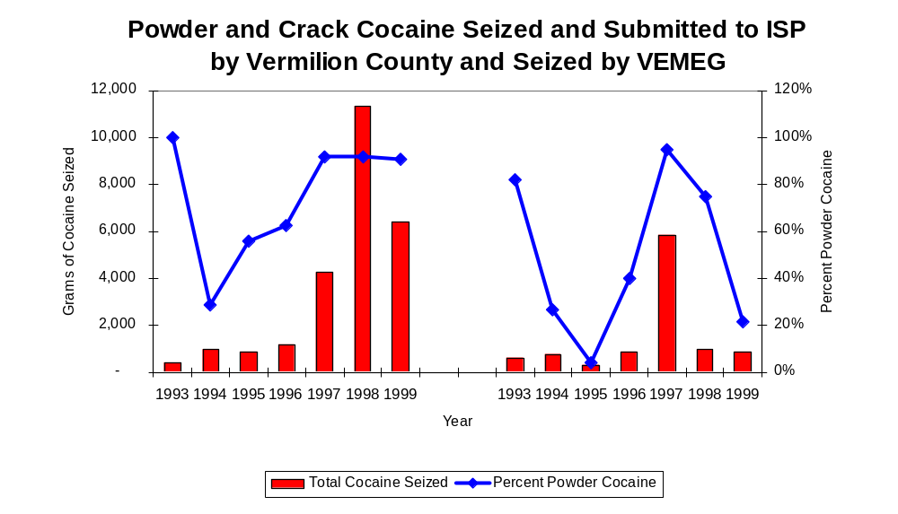
During the years analyzed, the proportion of all cocaine seized accounted for by powder cocaine varied in the region covered by VEMEG and for VEMEG. Although in 1993 proportion of all cocaine seized accounted for by powder cocaine was 82 percent of the cocaine seized in the region, this number dropped to 4 percent in 1995 and 22 percent in 1999. For VEMEG, between 1993 and 1999 the proportion of powered cocaine of all cocaine seized dropped slightly from 100 percent in 1993 to 91 percent in 1999 (Figure 16). However, in 1994, the proportion of all cocaine seized accounted for powder cocaine was only 29 percent, and did not reach 90 percent until 1997. In 1999, VEMEG's cocaine seizure rate of 8,740 grams per 100,000 population was almost eight-times greater than the cocaine seizure rate of 1,024 grams per 100,000 population in the region covered by VEMEG, but 44 percent less than the statewide cocaine seizure rate of 15,735 grams per 100,000 population (Map 3).
Figure 16
Source: Illinois State Police and VEMEG
VEMEG
Region

The total quantity of illegal drugs seized and submitted by law enforcement agencies in Vermilion County decreased 83 percent between 1993 and 1999, from 142,856 grams to 23,684 grams. On the other hand, the total quantity of illegal drugs seized by VEMEG increased dramatically, from 794,041 grams in 1993 to 4,796,463 grams in 1999.

Between 1994 and 1998, VEMEG reported no methamphetamine seizures, however, in 1999, VEMEG reported 80 grams of methamphetamine seized. In the region covered by VEMEG, between 1994 and 1999, 55 grams of methamphetamine were seized. In 1999, the seizure rate for VEMEG was 109 grams per 100,000 population, slightly higher than the state’s seizure rate of 97 grams per 100,000 population, but significantly higher than the seizure rate of 31 grams per 100,000 population for Vermilion County (Map 4).

Trends in Prosecutions for Drug Offenses and All Felonies

Although Illinois has one of the best court reporting systems in the country, the Administrative Office of the Illinois Court only collects information regarding the aggregate number of court filings. Currently, there are no statewide data available on court filings by offense type. The Administrative Office of the Illinois Courts reports data on felony criminal court cases. After screening a case and deciding it warrants further action, the state’s attorney must file formal charges in court. Felony cases can be punished by a probation term up to four years and incarceration for more than one year.

Between 1989 and 1999, the number of felony filings in the region covered by VEMEG increased 40 percent, from 407 to 569 (Figure 17).

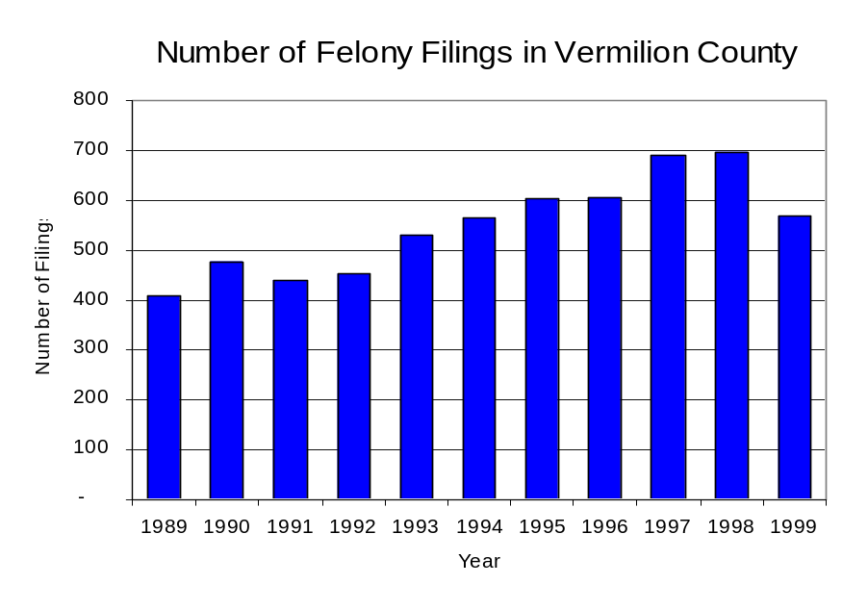
Figure 17
Source: Administrative Office of the Illinois Courts

Between 1989 and 1999, there were a total of 940 drug prosecutions initiated as a result of VEMEG arrests in Vermilion County. During this time, the number of VEMEG drug arrests varied by year; however, the number of arrests nearly doubled from 42 arrests in 1989 to 81 arrests in 1999 (Figure 18). Between 1991 and 1999, almost 100 percent of drug arrests by VEMEG resulted in prosecution. No prosecutions were reported in 1989 or 1990. Sixty-nine percent of VEMEG drug offender prosecutions during this period were for violations of the Controlled Substance Act. In some years, the proportion of arrests resulting in a prosecution exceeded 100 percent. This may be due to some differences in the timing of an arrest and the filings of charges, or could be due to the number of charges, rather than the number of defendants being reported by the unit. In addition, some offenders have charges filed, and a subsequent warrant issued, without an arrest taking place, which could also affect the number of prosecutions reported.

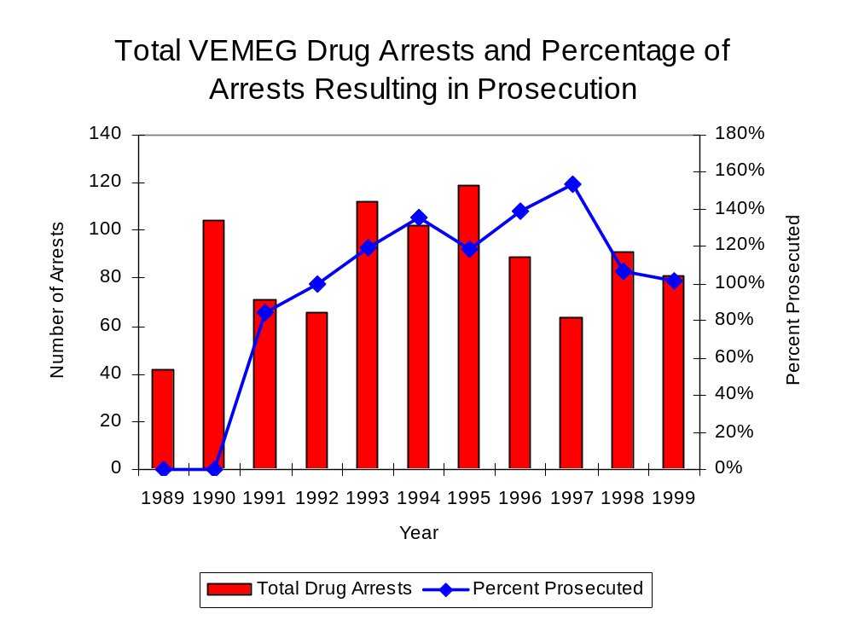
Figure 18
Source: VEMEG

Between 1989 and 1999, 73 percent (685) of the 940 drug offenders who were prosecuted as a result of VEMEG activity were convicted. Convictions for controlled substances accounted for 69 percent of all VEMEG initiated convictions during the period analyzed.

VI. Trends in Percent of Convicted Drug Offenders Sentenced to Prison

Anyone convicted of a felony in Illinois can be sentenced either to prison or probation, or receive conditional discharge. A number of factors influence the type and length of sentence imposed on convicted felons, including the severity of the crime, the offender’s criminal and social history, safety of the community and legislation affecting certain types of offenses. For some types of convictions, a sentence to prison is required by state statute.

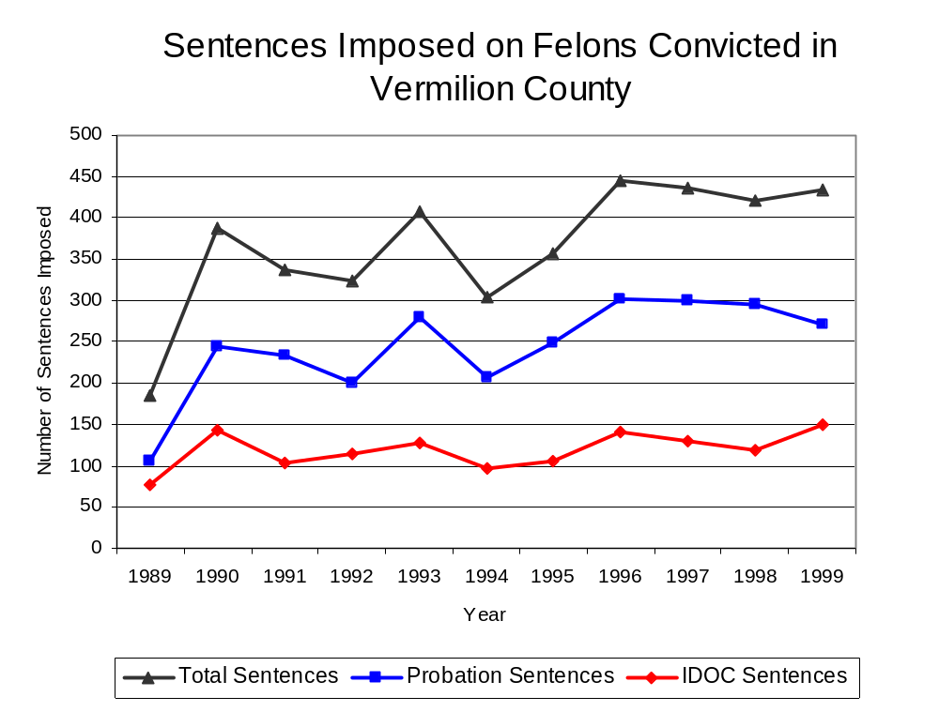
Between 1989 and 1999, the number of offenders convicted of a felony and sentenced in the region covered by VEMEG more than doubled, from 184 to 434. Although the number of convicted felons sentenced to the Illinois Department of Corrections (IDOC) increased 96 percent between 1989 and 1999, from 76 to 149; the proportion of felons sentenced to IDOC remained relatively stable during the same period. In 1999, 270 probation sentences were imposed on convicted felons, more than double the number of probation sentences in 1989 (Figure 19). As a result, the proportion of felons sentenced to probation increased eight percent from 58 percent in 1989 to 62 percent in 1999. Sentences other than prison or probation account for the remaining 3 percent of felony sentences imposed in 1999.
Figure 19
Source: Administrative Office of the Illinois Courts

Between 1991 and 1999, the number of VEMEG drug offenders convicted and sentenced increased slightly from 41 to 48, however in 1993, the number of felons sentenced rose to 105 offenders sentenced. During the period analyzed, the number of convicted VEMEG drug offenders sentenced to probation increased from 23 in 1991 to 26 in 1999, although in 1993 and 1997, the number of convicted VEMEG drug offenders sentenced to probation reached an all time high of 61. Similarly, the number of convicted VEMEG drug offenders sentenced to jail increased from zero to 2, while the number of drug offenders sentenced to prison increased from 18 to 20 (Figure 20). In 1999, among those VEMEG drug offenders convicted and sentenced, probation sentences accounted for the largest proportion (54 percent), followed by prison sentences (42 percent) and jail sentences (4 percent).

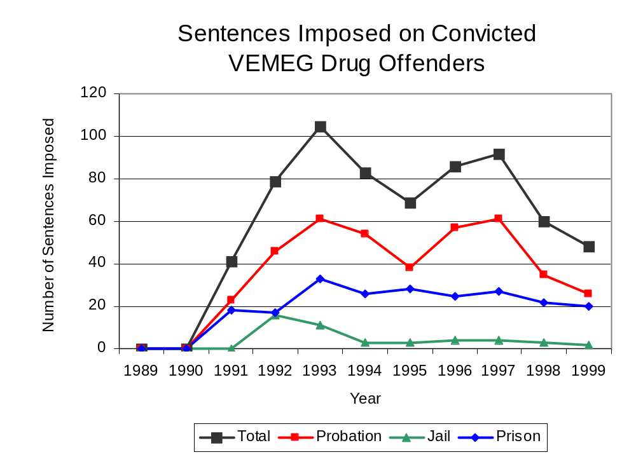
Figure 20
Source: VEMEG

Between state fiscal years 1989 and 1999, the number of new court commitments to IDOC’s Adult Division for drug offenses from the region covered by VEMEG tripled, from 8 to 26. The number of drug offender admissions by VEMEG also increased from zero to 19 between 1989 and 1999 (Figure 21). Thus, during the period analyzed, prison sentences resulting from VEMEG cases accounted for 91 percent of all drug-law violators sentenced to prison from the region where VEMEG operates.
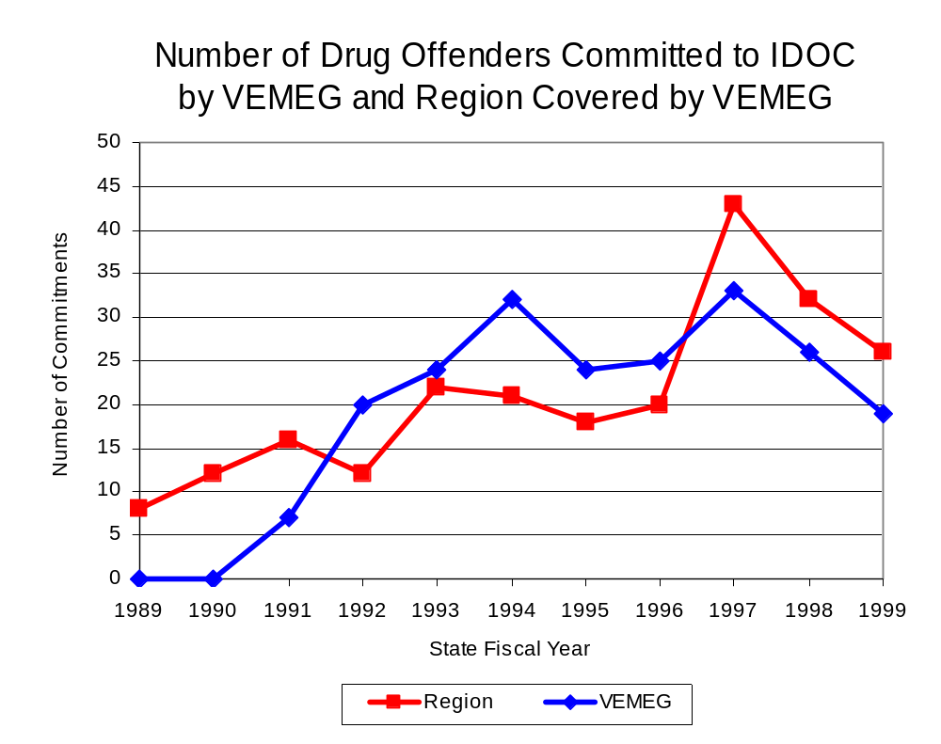
Figure 21
Source: Illinois Department of Corrections and VEMEG

During the period analyzed, drug offenders accounted for an increasing proportion of adults convicted and sentenced to prison from Vermilion County. In 1989, drug offenses accounted for 13 percent of all commitments to IDOC, compared to 19 percent in 1999 (Figure 22).
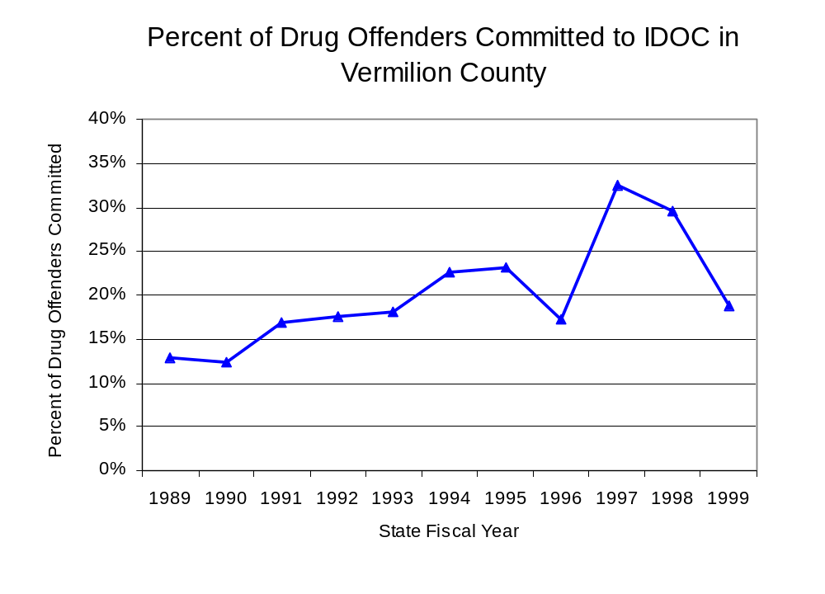
Figure 22
Source: Illinois Department of Corrections

Penalties for drug offenses were also examined between 1993 and 1999. Class 1 felonies accounted for the largest proportion (32 percent) of sentences to IDOC for drug offenses, followed by Class 2 felonies (28 percent), Class 4 felonies (21 percent) and Class 3 and Class X felonies (each 9 percent). Between 1993 and 1999, the number of felons committed per Class remained relatively stable, except in 1997 when the number of felons held for Class 1, 2 and 4 drug offenses increased (Figure 23).

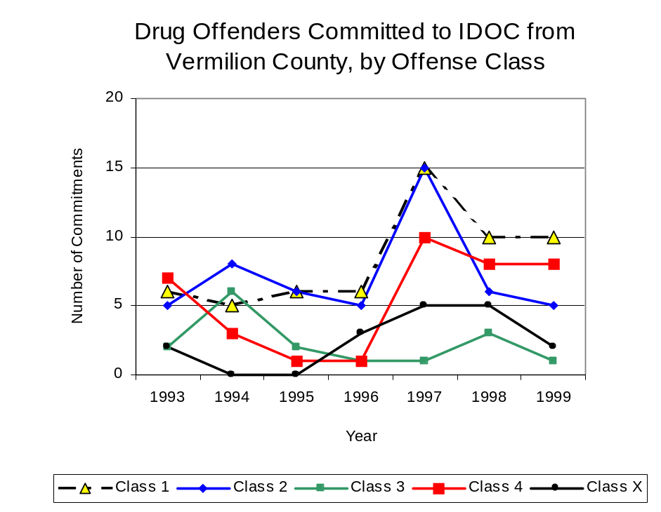
Figure 23
Source: Illinois Department of Corrections

Between 1993 and 1999, the average sentence length for all felony classes remained relatively unchanged, except for Class X felonies, which decreased from an average sentence length of 14 years in 1993 to an average sentence length of nine years in 1999.

VII. Trends in Drug Treatment Admissions in VEMEG Region by Drug Type

In addition to considering indicators of the extent and nature of drug abuse as reported through the criminal justice system (for example, arrests and prison sentences), there are indicators of substance abuse available from other Illinois social service agencies. Overseeing and supporting treatment for substance users, whether they are referred from the criminal justice system or elsewhere, is the responsibility of the Illinois Department of Human Services’ Office of Alcoholism and Substance Abuse (OASA). It is important to note, however, that while OASA data represent the majority of the overall demand for substance abuse treatment in the state, some private programs provide treatment services to a smaller but significant number of clients who may not be included in the state’s reporting system.

In state fiscal year 1999, OASA reported 1,352 admissions for alcohol or drug abuse treatment from Vermilion County, more than triple the 407 admissions in 1989 (Figure 24). Among the 1,352 admissions to substance abuse treatment in state fiscal year 1999, 47 percent (633) reported alcohol as their primary substance of abuse, while abuse of illicit substances accounted for 49 percent. Five percent reported no primary substance of abuse.

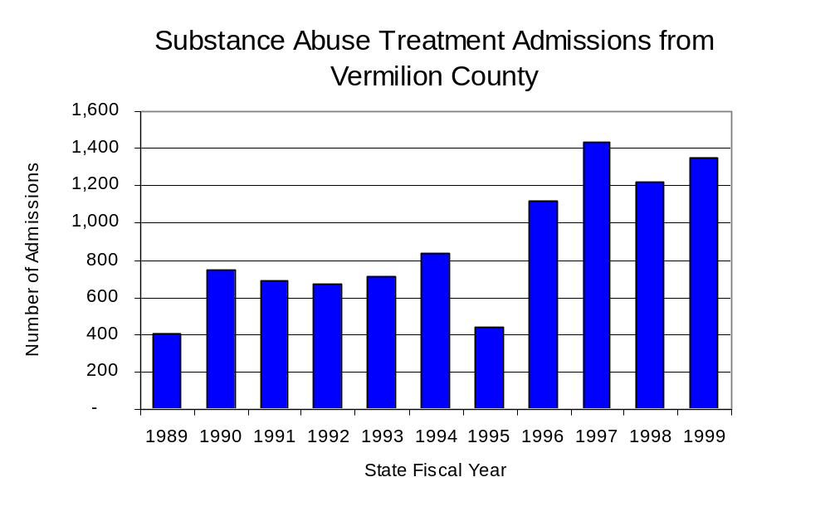
Figure 24
Source: Illinois Department of Human Services’
Office of Alcoholism and Substance Abuse
While drug treatment admissions can be considered a measure of the demand placed on a specific component of the human services system within Illinois, the extent and nature of drug treatment admissions could also be indicative of the substance abuse problem within a particular region. In some respects, the characteristics of those admitted to drug treatment can be considered a profile of the most serious drug abusers in the community, since admission to treatment requires a documented, formal assessment of a drug problem and a level of substance abuse warranting treatment. By comparing the types of drugs of abuse reported by those admitted to substance abuse treatment with the types of drugs involved in law enforcement agency arrests, one can get a sense of the degree to which arrests reflect the drugs which are most problematic within a community.

In the following analyses, the percent of arrests accounted for by drugs classified under Illinois’ Controlled Substances Act (primarily cocaine, heroin, and methamphetamine) versus the Cannabis Control Act (marijuana) across the participating agencies combined, non-participating agencies combined and VEMEG are compared to the proportion of drug treatment admissions accounted for by these groups of substances. From these comparisons, a number of general conclusions can be made. First, the proportion of arrests made by VEMEG accounted for by drugs other than marijuana (Controlled Substances Act offenses) was higher than the proportion of drug treatment admissions from the covered region accounted for by these substances. However, when compared to the arrests made by both participating and non-participating agencies, the arrests made by VEMEG were closer to the number of individuals admitted for substance abuse for substances other than marijuana. The majority of arrests by local police departments (including those participating in VEMEG and non-participating agencies) were for cannabis offenses. Thus, while local arrests may reflect the most widely available and used drug in the region, they did not tend to involve the substances considered to be most serious (i.e., felony versus misdemeanor) nor the substances for which individuals were seeking and receiving treatment (Figure 25).

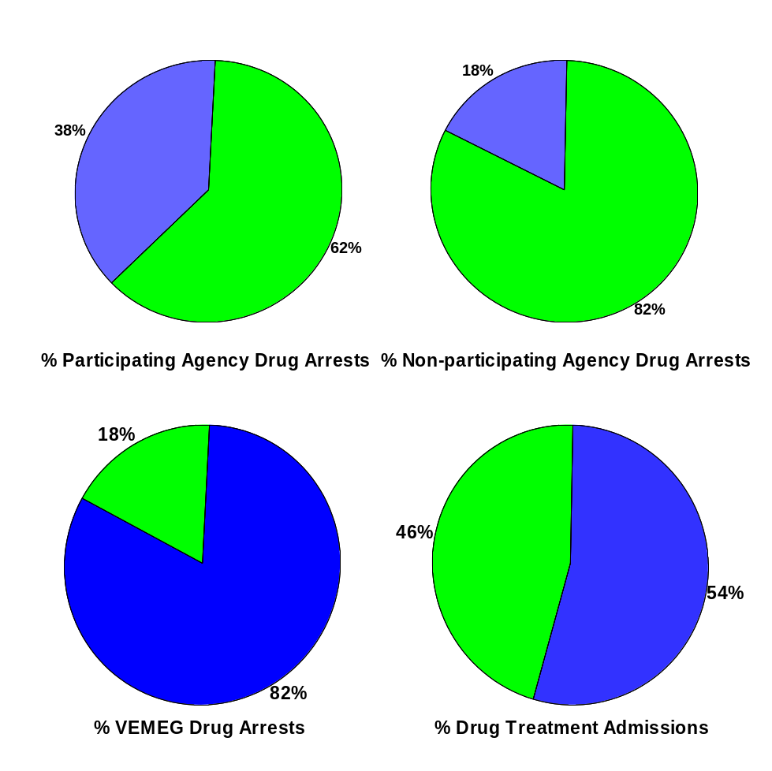
CannabisControlled Substances
Comparison of Drug Arrests by VEMEG and Participating and Non-participating Agencies vs. Drug Abuse Treatment Admissions in Vermilion County, 1999
Source: Illinois Department of Human Service's Office of Alcoholism and Substance Abuse and VEMEG
Figure 25

VIII. Trends in Drug Exposed Births

Illinois continues to experience the effects of prenatal substance abuse. In Illinois, if a baby is born and thought to have been exposed to illegal substances or alcohol, either through observation by physicians or toxicology tests, the case is reported to the Illinois Department of Children and Family Services. These cases are then investigated by DCFS to verify the child’s prenatal exposure to either alcohol or illegal substances. Between state fiscal years 1989 and 1999, nearly one-half (50) of Illinois’ 102 counties reported at least one case of a substance-affected infant.

Between state fiscal years 1989 and 1999, the number of drug-exposed infant cases reported in the region covered by VEMEG increased from one reported case to 15 reported cases, with the largest increase occurring between state fiscal year 1992 and 1993. Between state fiscal years 1989 and 1999, 87 percent of all cases reported, were verified as involving prenatal drug use by a DCFS investigation. Mirroring the trend of reported cases, verified cases of drug-exposed infants in the VEMEG region also increased between 1989 and 1999 from zero to 14 (Figure 26).

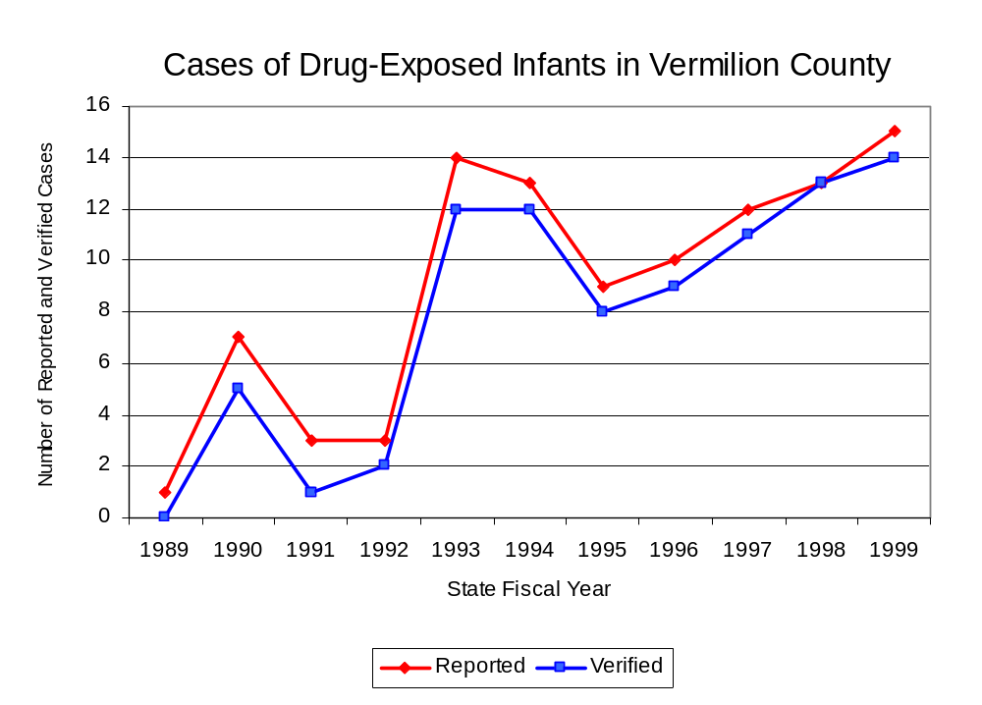
Source: Department of Children and Family Services
Figure 26

IX. Summary of Drug Situation

Although the distribution of illegal drugs is difficult to measure precisely, data obtained from criminal justice sources can be helpful in estimating drug availability. Information from a recent survey of Illinois drug enforcement units, as well as the most up-to-date data available on drug price, are presented as indicators of the drug supply in Illinois.

In 1995, 1996 and 1998, the Authority conducted a survey of each MEG and task force in Illinois to gauge the perceived availability of drugs in the areas they cover. Questions were asked concerning the availability of specific drugs, and results were analyzed by region of the state. MEGs and task forces are classified as being either urban, rural or mixed urban/rural based upon the classification of the county(s) that each unit covers, and, for purposes of this report, are compared to the average of similar units.

According to VEMEG survey responses, cannabis, cocaine and crack continued to be the most visible drugs on the street and were all reported to be “readily available” across all regions analyzed. Although perceived availability of all the drug types examine remained relatively unchanged across Illinois and other mixed urban/rural regions, the perceived availability increased slightly, since the 1996 survey, in the region covered by VEMEG. Both methamphetamine and LSD were reported as moderately available across all areas that were examined, while PCP and heroin were perceived to be available at a lesser degree. However, the perceived availability of cocaine and crack was slightly greater in the region covered by VEMEG and in other mixed urban/rural than across Illinois (Figure 27).
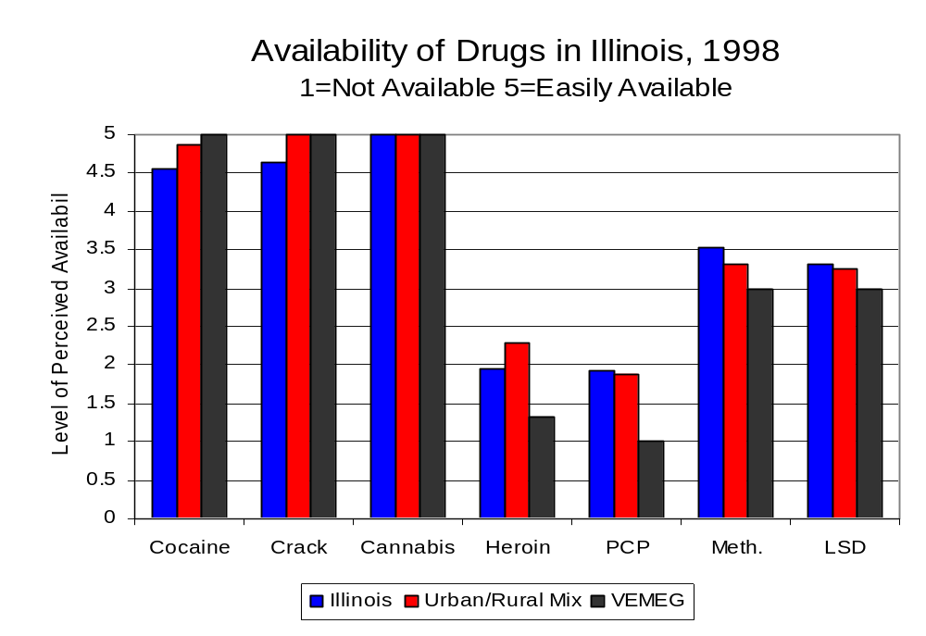
Figure 27
Source: Authority Survey of Illinois MEGs and task forces
Another market indicator that can be used to assess availability is drug price. Lower prices tend to suggest a sufficient supply to meet demand, while increasing prices indicate decreased availability.

Based on a statewide survey of MEG and task force units, the change in the average price of all the drugs examined, between 1996 and 1998, varied across all regions surveyed. The 1998 average price of cocaine reported by VEMEG was $100 per gram, compared to $98 per gram across Illinois and $103 per gram reported by all MEGs and task forces in other mixed urban/rural regions (Figure 28). On the other hand, the average price of crack in the region covered by VEMEG was reported as $100 per gram, lower than the price of $102 per gram across Illinois and the price of $104 per gram reported by all other MEGs and task forces in mixed urban/rural regions. In 1998, the average price of cannabis was reported as approximately $7 per gram in the VEMEG region and in mixed urban/rural regions and $8 per gram across Illinois.

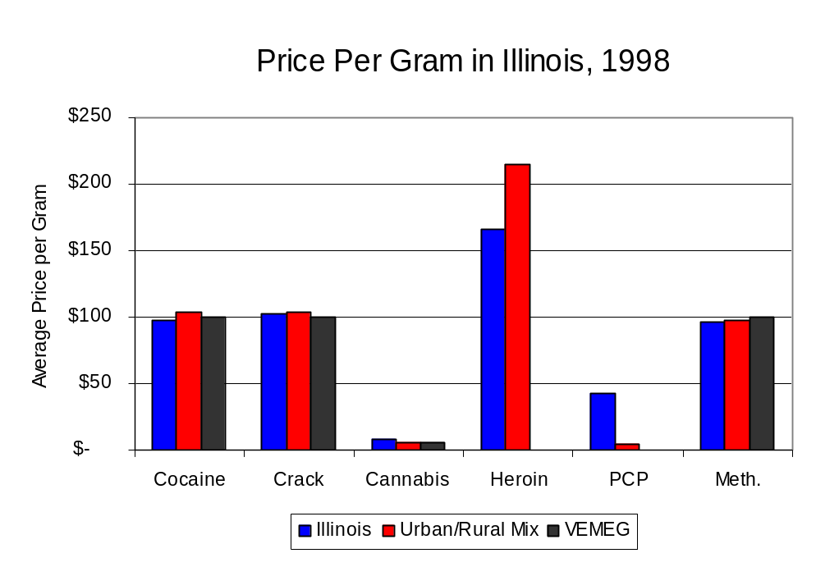
Figure 28
Source: Authority Survey of Illinois MEGs and task forces

X. Appendices
1999 Percent of Illinois'
County-level Population Covered by an Authority-funded Multi-jurisdictional Enforcement Group or Task Force
Map 1
* Shaded counties indicate that at least one law enforcement agency within the county participates in a MEG or Task Force
Percent of County Population Covered by MEG or Task Force

1999 Illinois
Cannabis
Seizure Rates, by County
Map 2
Cannabis Seizure Rate
(rate per 100,000 population)
1999 Illinois
Cocaine
Seizure Rates, by County
Map 3
Cocaine Seizure Rate
(rate per 100,000 population)
1999 Illinois Methamphetamine
Seizure Rates, by County
Map 4
Methamphetamine Seizure Rate
(rate per 100,000 population)
XI. Bibliography

Administrative Office of the Illinois Courts, Annual Report to the Supreme Court of Illinois.
1989 through 1999 reports, Springfield, Illinois.

Administrative Office of the Illinois Courts’ Probation Division, Statewide Probation Data
Report. 1989 through 1999 reports, Springfield, Illinois.

Illinois Department of Human Services’ Office of Alcoholism and Substance Abuse. Data
provided for state fiscal years 1989 through 1999, Springfield, Illinois.

Illinois Department of Children and Family Services, Child Abuse/Neglect Statistics Report,
1989 through 1999 reports, Springfield, Illinois.

Illinois Department of Corrections. Data provided for fiscal years 1989 through 1999,
Springfield, Illinois.

Illinois State Police, Crime in Illinois. 1993 through 1999 reports, Springfield, Illinois.

Illinois State Police, Drug Statistics Report. Monthly reports, January 1989 through
December 1999, Springfield, Illinois.

Vermilion County Metropolitan Enforcement Group. Monthly reports, January 1989 through December 1999, Danville, Illinois.

U.S. Bureau of the Census.


George H. Ryan, Governor
Peter B. Bensinger, Chairman
Candice M. Kane, Executive Director

